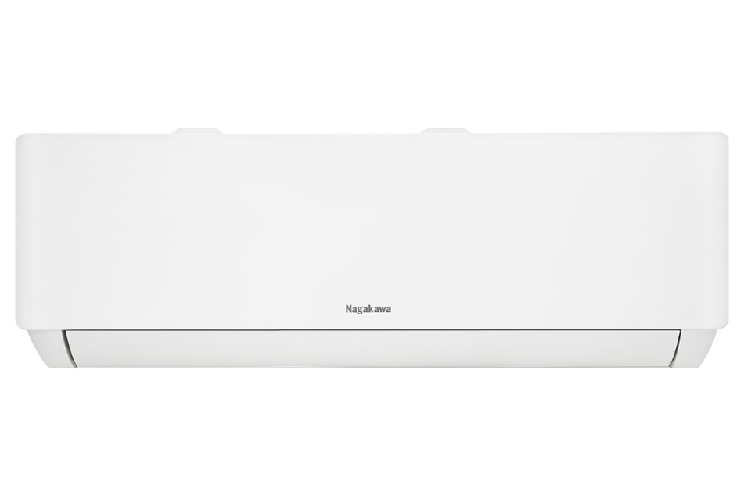

**7,140,000 VND**

(-17%)No copper pipes and supplies will be given away.Delivery only, no installation.

**Technical specifications of Nagakawa Inverter 1 HP air conditioner NIS-C09R2T28**

* Machine Type:

1 way (cooling only) With Inverter

* Cooling capacity:

1 HP - 9,000 BTU

* Effective cooling range:

Under 15m² (from 30 to 45m³)

* Dust filter, antibacterial, deodorant:

6 in 1 filter

* Power saving technology:

EconomyInverter

* Rapid cooling:

Turbo

* Utilities:

Favorite setting mode I-set Sleep operating mode Dehumidification function I Feel temperature sensor Turn on and off timer Temperature display screen on the indoor unit Automatically restarts when power is restored

* Power consumption:

0.87 kW/h 5 stars (Energy efficiency 4.51)

* Cooler:

Length 79 cm - Height 27.5 cm - Thickness 20.3 cm - Weight 8 kg

* Outdoor:

Length 71.2 cm - Height 45.9 cm - Thickness 27.6 cm - Weight 19 kg

Introducing the company 

- Vietnamese brand.  
- Established in 2002.  
- Diverse business products: air conditioners, dishwashers, induction cookers,.... with product prices easily accessible to consumers.  
- Achieved many outstanding achievements: Top 100 best products for families and children (2023), golden brand for Vietnamese health (2019),...

[**Detailed review of Nagakawa Inverter 1 HP NIS-C09R2T28 air conditioner**](https://www.dienmayxanh.com/kinh-nghiem-hay/danh-gia-chi-tiet-may-lanh-nagakawa-inverter-1-hp-1537694)

[***Nagakawa Inverter 1 HP NIS-C09R2T28 air conditioner***](https://www.dienmayxanh.com/may-lanh/nagakawa-inverter-1-hp-nis-c09r2t28)***has the ability to cool quickly but still ensures energy saving efficiency. Furthermore, this air conditioner model can also dehumidify independently, helping the room become dry on humid days.***

**Design**

**Cooler:**

Designed in  a familiar **horizontal rectangular shape** with high-quality plastic shell material and a **delicate white color** scheme .

**Outdoor:**

- Designed in **a rectangular shape** with durable plastic shell material.

**- The heatsink** material is made of pure copper with a **spiral groove design** , and is also **covered with a yellow Golden Fin layer** that has good corrosion resistance, helping to increase the durability of the machine during its operating time. .

- Both the indoor and outdoor units of [Nagakawa air conditioners](https://www.dienmayxanh.com/may-lanh-nagakawa) use **gas pipes made of copper** , providing fast and deep cooling.

- Air conditioners **use** environmentally friendly R32 gas and provide optimal cooling efficiency.

**Refrigeration technology**

- [The air conditioner](https://www.dienmayxanh.com/may-lanh) has **a capacity of 1 HP** , meeting the cooling capacity for rooms with an area of **​​less than 15m²** .

- **Turbo fast cooling mode** : The compressor motor will operate at maximum capacity, helping the temperature in the room to be quickly lowered to the temperature set by the user, thanks to which the user feels almost cool **. as immediately** after activating this mode.

**Air blowing mechanism**

**I Feel temperature sensor** : Allows users to automatically adjust the air conditioner's operating mode at the remote location thanks to the integrated sensor, thereby helping users feel **cool and comfortable even Sit anywhere near the air conditioner remote** in the room.

**Power saving technologies**

- **Inverter technology** : Able to flexibly adjust compressor rotation, helping the air conditioner **maintain a stable temperature** inside the room while still **consuming as little power as** possible.

- **Energy saving function (Economy)** : Supports air conditioners with the ability **to save electricity to an optimal level** , contributing to reducing monthly electricity costs for users.

**Air filtration ability - health**

**6-in-1 filter** : Made from 6 filters including Photocatalyst, Ion Silver, Active Carbon, Catechin, Vitamin C and Catalyst, thereby providing **optimal dust and allergen filtering** ability , while Effectively eliminates **odors** , returns **fresh air** to the room, and even **helps beautify** the user's skin.

**Utilities**

- [Timer to turn the machine on and off](https://www.dienmayxanh.com/kinh-nghiem-hay/cac-che-do-thuong-thay-tren-may-lanh-795107#hmenuid4) : Able to schedule the machine to turn on or off for up to 24 hours, helping users **control the time to use the air conditioner** , convenient for use at night.

- [Automatically restarts when there is power](https://www.dienmayxanh.com/kinh-nghiem-hay/cac-che-do-thuong-thay-tren-may-lanh-795107#hmenuid9) : Able to automatically restart when a sudden power outage occurs, without the user having to reset the cooling mode to the original.

-  **I-set favorite setting mode** : This [Nagakawa Inverter air conditioner](https://www.dienmayxanh.com/may-lanh-nagakawa?g=may-lanh-inverter)  has the ability to remember the user's favorite settings, thereby  **reducing operations and time spent setting up** the air conditioner each time it is used.

-  [Sleep operating mode](https://www.dienmayxanh.com/kinh-nghiem-hay/che-do-ngu-dem-tren-may-lanh-la-gi-631348) :  This [Nagakawa 1 HP air conditioner](https://www.dienmayxanh.com/may-lanh-nagakawa?g=1-hp)  can automatically increase the temperature at night,  **avoiding the cold feeling**  and helping users get better sleep.

*In short, the Nagakawa Inverter 1 HP NIS-C09R2T28 air conditioner is suitable for all families today when they need to cool a small room with an area of ​​less than 15m². Furthermore, this air conditioner is very suitable for those with sensitive health when staying in an air-conditioned room thanks to its sleep mode and 6-in-1 filter.*